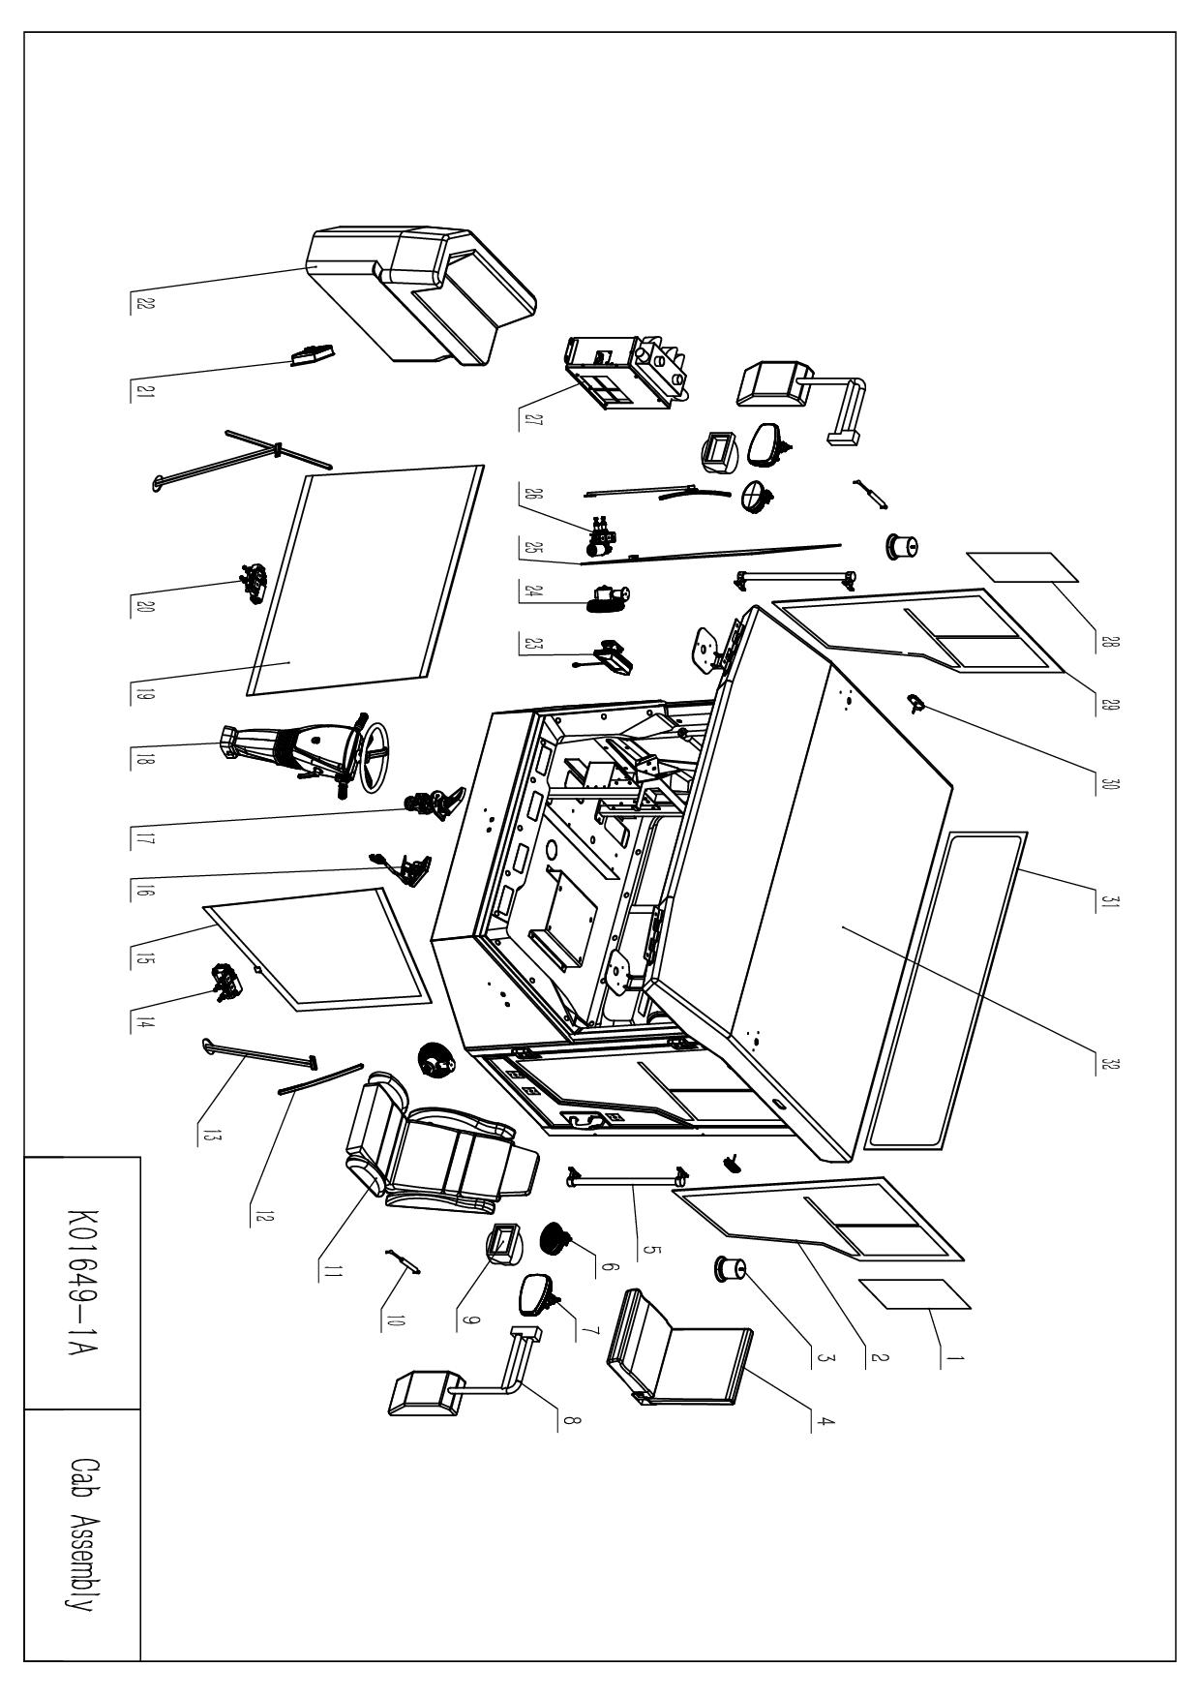

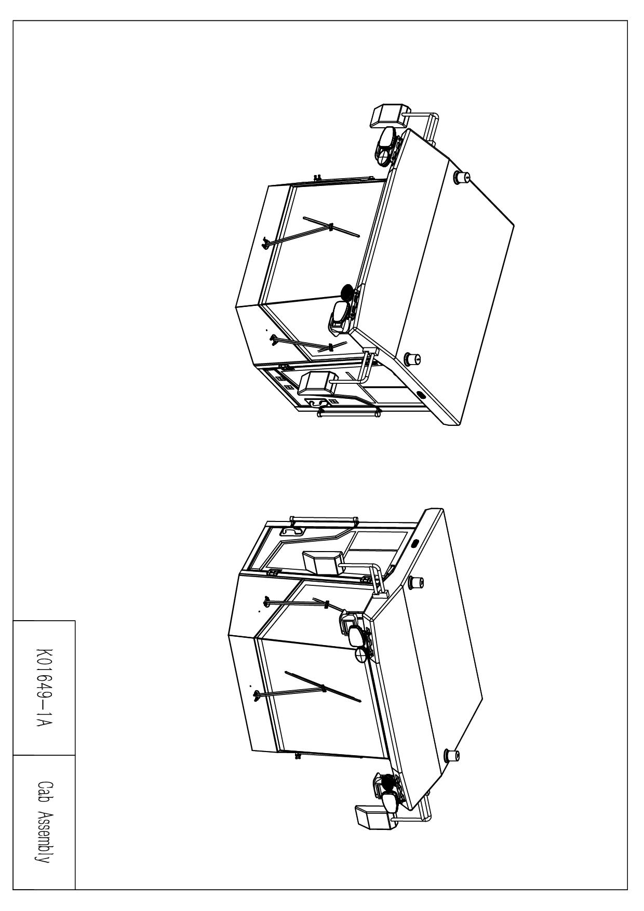

K01649-1A Cab Assembly
Num | Part Num. | Description | Quantity | Num | Part Num. | Description | Quantity
1 | KODIAK028 | Left door observation glass | 1 | 17 | 351571 | Accelerator Pedal | 1
2 | KODIAK029 | Left door glass | 1 | 18 | C031-0005 | Column Streeing | 1
3 | LTL1300 | Circular Strobe | 2 | 19 | KODIAK031 | Front Glass | 1
4 | 520x420-B | Folding Seats | 1 | 20 | 11195BG30I0 | Front wiper motor | 1
5 | KODIAK036 | Armrest | 2 | 21 | CR9042 | Display | 1
6 | LML-3263 | Work Lights | 2 | 22 | KODIAK017 | Interior | 1
7 | LML-WH9102 | Front combination headlights | 2 | 23 | TM70LC | Display | 1
8 | HY-0169 | Rosco Side Mirror | 2 | 24 | KODIAK037 | Small fan | 2
9 | BC-XK013 | Beacon | 2 | 25 | KODIAK032 | Right Front Glass | 1
10 | 85-259-350N | Gas Spring | 2 | 26 | 11195BH30I0 | Right wiper motor | 1
11 | AZ1662511011 | Seats | 1 | 27 | TY46G15AB-ZGZQ-09 | Heat Exchanger | 1
12 | 136.2265.GA.04 | Wiper Blade | 3 | 28 | KODIAK033 | Right door observation glass | 1
13 | 127.3204.GA.D4 | Wiper Arm | 3 | 29 | KODIAK034 | Right door glass | 1
14 | 11195BH30D0 | Left wiper motor | 1 | 30 | SM7009 | Side-Lamp | 2
15 | KODIAK030 | Left Front Glass | 1 | 31 | KODIAK035 | Back Glass | 1
16 | 4613170230 | Brake Pedal | 1 | 32 | K01649-1 | Cab | 1

